Jabra Elite 65e brings ‘total’ noise cancellation
solution to consumers

~ Newest addition to Elite franchise of headphones comes with both active and passive noise cancellation, ensuring an undisturbed sound experience ~

Sydney, Australia, March 21, 2018 – Jabra expands its Elite franchise, a family of headphones and earbuds engineered for superior sound to provide the best combined voice and music experience, with the Jabra Elite 65e. These neckband wireless earbuds are engineered for best-in-class wireless calls and music and provide two levels of noise cancellation including Jabra’s leading Active Noise Cancellation (ANC) solution, challenging existing solutions in the market. On top, the Jabra Elite 65e offers incredible conversation quality with three-microphone technology that creates a noise-blocking zone – making sure your voice is conveyed with crystal-clear clarity.

Standing on a noisy train platform? Walking through a busy high street? Cancel out the background sound with Jabra’s unrivalled total noise cancellation solution – with optimised engineering for both the active and passive noise cancellation.

Total noise cancellation solution
The first level consists of the development and design of the earbuds and Jabra EarGels™. The optimal engineering of the mechanical fit and the design of the oval earbuds – developed by Jabra to ensure a better fit in the ear canal – in combination with the eargels for a perfect grip, provide an optimal seal for the passive noise cancellation of ambient sounds. Extensively tested in our sound lab, the eargels help improve the quality of your listening experience – not only adding passive noise cancellation but also refining the bass in your music. You can listen to your music the way you want to hear it and the companion Jabra Sound+ app allows you to personalise your music to the sound that suits you.

The second level is the more known technology of Active Noise Cancellation that digitally removes additional noise levels. Having included ANC in professional headsets for years, Jabra now brings leading business grade ANC to consumers – providing superior total noise cancellation to the wider audience.

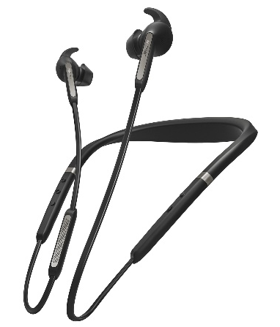
Best-in-class voice experience
Drawing on the GN Group’s long-standing audio, headset and hearing aid expertise, the Elite franchise is engineered to meet the needs of those users looking not only for outstanding music quality and voice capabilities, but also for consumers who are using voice assistants. Voice is increasingly becoming the tool of choice in the way we communicate with technology. With the Elite 65e you can instantly connect to Alexa, Siri® or Google Assistant™**, allowing you to quickly get the information you need – whether that be setting appointments, finding nearby events, or having your messages read back to you. Bluetooth 5.0 allows you to seamlessly connect the earbuds to a smartphone. The Jabra Elite 65e can be used all day, wherever you go, as it has a battery that lasts up to 8 hours when using ANC, and an incredible 13 hours with ANC turned off. And the premium design means that you can comfortably wear Elite 65e for just as long as the battery life.

In addition to the best-in-class voice and music experience, the Jabra Elite 65e comes with the security of a two-year warranty against dust and water ingress and features an IP54-rated design.

Calum MacDougall, SVP at Jabra said: “The Jabra Elite 65e is perfect for the on-the-go user that wants noise blocked out, allowing great conversations and music. We are well-known for our noise cancellation capabilities in the enterprise scene, and it is this professional engineering that allows us to offer an unrivalled solution for consumers. The voice command capabilities and outstanding battery life, in combination with the comfortable fit, make the earbuds your best all-day, everyday companion.”

Key features of the Elite 65e:
- The best voice experience: Enjoy incredible conversation quality with 3-microphone technology
- Professional-grade ANC: Cancel out background sound with professional-grade Active Noise Cancellation that uses 2 microphones in each earbud to deliver noise cancelling that meets business standards
- Day-long power: Battery that lasts up to 8 hours when using Active Noise Cancellation, and an incredible 13 hours with ANC turned off
- Unbeatable durability: Featuring an IP54-rated design, the Elite 65e comes with a 2-year warranty against water and dust*

Find out more about the products in the Jabra Elite family at: www.jabra.com/elite

Availability

The Jabra Elite 65e will be available in late April from selected retailers.

* Registration required with the Jabra Sound+ app
** Operating System dependent

PR CONTACTS
LEWIS Communications
Laura Sanford Lucy White
laura.sanford@teamlewis.com lucy.white@teamlewis.com
02 8599 1000 02 8599 1000

About Jabra
Jabra is a leader in engineering communications and sound solutions – innovating to empower both consumers and businesses. Proudly part of the GN Group, we are committed to letting people hear more, do more, and be more than they ever thought possible. Through sound, we help transform lives. Jabra engineering excellence leads the way, building on 150 years of pioneering work. This allows us to create integrated headsets and communications tools that help professionals work more productively; and wireless headphones and earbuds that let consumers better enjoy calls, music, and media. Jabra employs close to 1,100 people worldwide, and reported annual revenue of DKK 4bn in 2017. The GN Group, founded in 1869, operates in 100 countries and delivers innovation, reliability, and ease of use. Today, GN employs more than 5,500 people, and is Nasdaq Copenhagen listed.
GN makes life sound better. www.jabra.com
© 2017 GN Audio A/S. All rights reserved. Jabra® is a registered trademark of GN Audio A/S. All other trademarks included herein are the property of their respective owners (design and specifications are subject to change without notice).

