Jabra launches the Evolve 75e, the world’s first professional UC-certified wireless earbuds

- Pioneers in sound bring the around-the-neck wireless earbud design to the workplace
- Skype for Business certified three-microphone technology creates a unique talk-zone
- Active Noise Cancelling (ANC) and ‘busylight’ allow users to fully concentrate at work

Sydney, 23 January 2018 – Jabra, a leader in professional communications and sound solutions, today announces the availability of the Evolve 75e, the headset engineered to be the first professional UC-certified wireless earbuds. The new edition to the market-leading Evolve range of professional headsets is Skype for Business certified and features Active Noise Cancelling (ANC) and up to 14 hours of battery life on a single charge – all neatly fitted in the around-the-neck wireless earbud design.

The Evolve 75e’s design brings a familiar consumer design into a professional environment and still includes all the winning features of the Evolve range: wireless freedom, great sound, UC-compatibility, ANC and busylight. Research unveiled that the majority of today’s flexible workers (78%)¹ say their personal productivity at the office is impacted by noise and interruptions. The earbud form factor power bundle is the ultimate business tool for sound and freedom helping to maintain collaboration, concentration and productivity in busy, open plan offices without the need for designated quiet rooms.

Currently 31% of business professionals wear earbuds in the workplace². The Evolve 75e has been designed to meet this demand by leveraging Jabra’s unique microphone expertise. The Skype for Business certified three-microphone technology creates a unique talk-zone, offering a professional grade call quality. This professional sound is engineered in a form factor people love to wear: an around-the-neck, wireless earbud design. This wearing style offers the flexibility and mobility to work effectively wherever you are.

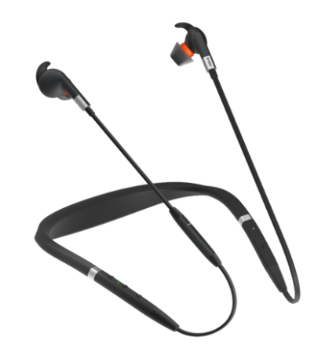
The Evolve 75e improves collaboration in the office and gives flexibility to those who make work calls both inside and outside the office, all day long. The headset features lithium-ion battery technology, allowing to fully charge in just two hours and providing up to 14 hours of battery life. Multiple fitting options or gels and EarWings give amazing seal and comfort throughout the day. The magnetic earbuds conveniently snap together when not in use and activates power-nap mode.
The wireless earbuds have smart controls for work and play. Five buttons allow for quick control of calls and music, including a smart button for one-touch access to all major virtual assistants, including Siri, Google Now, Cortana and Bixby. The vibrating neckband gives silent notifications to make sure users don’t disturb others and that calls are never missed.
“The Jabra Evolve 75e delivers professional sound for calls and music that lasts as long as you need in a wireless earbud design. These first professional UC-certified wireless earbuds meet the needs of today’s mobile and increasingly connected worker who demands the same user experience from both consumer and professional solutions,” said Holger Reisinger, SVP at Jabra. “The powerful headphones with ANC allow you to fully focus and concentrate, whatever the noise around you, in a wearing style popular with mobile office workers.”
Evolve 75e at a glance:
- Design – Wireless earbud form factor
- Amazing sound – Skype for Business certified sound quality, engineered to drive professional UC
- Enhanced productivity – ANC and integrated busylight
- Endurance – Up to 14 hours of battery
- Lithium-ion battery technology – Fully charged in just two hours
- Comfort – Multiple fitting options
- Smart controls – One-touch Siri® and Google Now™

Find out more about the Jabra Evolve 75e at: www.jabra.com.au/evolve75e

1 Jabra Knowledge Workers Survey, Lindberg 2015
2 Jabra Knowledge Workers Survey, Lindberg 2015

Pricing and availability
The Jabra Evolve 75e is now available in Australia and New Zealand
Click here for more information on Jabra Enterprise Partners

About Jabra
Jabra, part of the GN Group, is a leading developer and manufacturer of communications and sound solutions. We are committed to letting people hear more, do more and be more than they ever thought possible. We believe that through sound, we can transform lives. Jabra innovates and empowers with sound solutions for businesses and consumers, producing corded and wireless headsets, portable and in-office speakerphones, and sports earbuds. Jabra employs 1,000 people worldwide, and produced an annual revenue of DKK3.5 bn in 2016. The GN Group operates in more than 90 countries, and has almost 150 years’ experience in innovation and delivering reliability and ease of use. Founded in 1869, employing over 5,000 people, and listed on Nasdaq Copenhagen, GN makes life sound better. www.jabra.com

© 2016 GN Audio A/S. All rights reserved. Jabra® is a registered trademark of GN Audio A/S. All other trademarks included herein are the property of their respective owners. (Design and specifications subject to change without notice).

