PRESS RELEASE
Jabra delivers calls and music quality with local availability of entire Elite Series
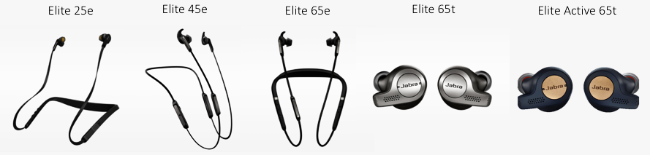
Enjoy the best wireless calls and music experience with Elite series headphones, engineered for life on the go.

Sydney, 8 May 2018 – Jabra today announces the local availability of three new Elite products, completing the full range of Elite headphones and earbuds, engineered for superior sound to provide the best combined voice and music experience.
New to the series, the Jabra Elite 45e and the Jabra Elite 65e feature neckband wearing styles and superior stereo calls and music. The Elite Active 65t is the latest ‘true wireless’ sports earbud solution in Jabra’s portfolio, following on from the widespread success of the Jabra Elite Sport.
These new stereo solutions demonstrate Jabra’s extensive audio experience - backed by research that highlights the daily usage of headphones by frequent users focuses on calls (58% of users each day), music (53%) and voice control (35%). The Elite series is engineered to meet the needs of users looking not only for outstanding music quality, but also for strong voice capability, whether they’re making calls or increasingly using voice assistants such as Alexa, Siri or Google Now. With the Elite series, users no longer compromise between headphones designed for music or a headset designed for voice and calls.
Drawing on the GN Group’s long-standing audio expertise - encompassing professional, consumer and medical grade solutions - each Elite product in the series contains unique microphone configurations to ensure users will always be heard, whether speaking to a voice assistant or on a call, and whether you’re indoors or out on the street. In addition, the companion Jabra Sound+ app allows users personalise their music to their preferred sound.
While delivering a market-leading voice and music experience and durability, each of the Elite products that Jabra has launched has its own specific features:
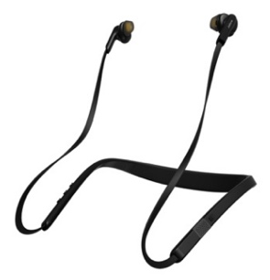
Elite 25e: Engineered for all-day music and calls. The Elite 25e headphones are perfectly powered: One charge delivers up to 18 hours of battery life – giving you the freedom to stay connected anytime and anywhere. The neckband has bendable flex zones and the design will ensure a great fit and all-day comfort. By enhancing the fit with Jabra’s EarGels™ users get better in-ear sound. The eargels and speakers are engineered for an immersive audio experience. With a dedicated voice control button and message read out, you have one-touch access to Siri®, and Google Now™, letting you access information hands-free, on the move.
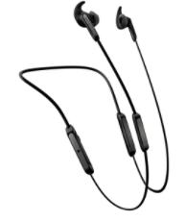
Elite 45e: Engineered for the best calls and music with ultimate comfort. The Elite 45e is for users who want the best combined voice and music experience in a headset with a discreet design and a great fit. This soft neckband (with memory wire) headset has a lightweight form factor and a unique box microphone solution that delivers the clearest voice communication on any stereo wireless headphone.

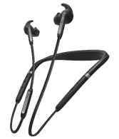
Elite 65e: Engineered for ‘total’ noise cancellation for today’s professional. The Elite 65e deliver best-in-class wireless calls and music and provide two levels of noise cancellation including Jabra’s leading Active Noise Cancellation (ANC) solution, challenging existing solutions in the market. On top, the Elite 65e offers incredible conversation quality with three-microphone technology that creates a noise-blocking zone – making sure your voice is conveyed with crystal-clear clarity. Instantly connect to Alexa, Siri® or Google Assistant™**, and quickly get the information you need. The Jabra Elite 65e can be used all day, as it has a battery that lasts up to 8 hours when using ANC, and an incredible 13 hours with ANC turned off, all housed within a premium design.

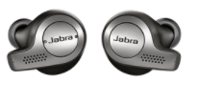
Elite 65t: Engineered for the best true wireless voice and music experience. The Elite 65t is a third-generation true wireless earbud aimed at those who want the best voice and music experience without wires. It is engineered to ensure a stable wireless connection and best call and voice quality. The 65t includes one-touch access to Siri®, and Google Now™, new integration for Amazon Alexa on-the-go and has up to 15 hours of battery life (with cradle).

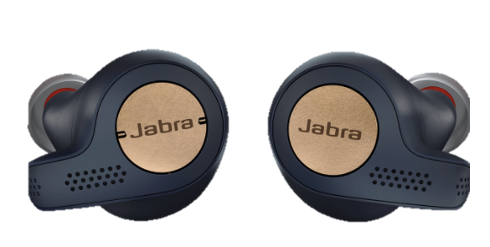
Elite Active 65t: Engineered for active lifestyles, for users who want a true wireless voice and music experience while working out. The Jabra Elite Active 65t is for those who want the features of the Elite 65t, while being able to use the earbuds in a sports or training setting. The earbuds have enhanced grip, through special coating, integrated accelerometer for tracking features and IP56 sweat, water and dust certification. The Elite Active 65t has five hours of listening time on one charge with two additional charges in the cradle.
“We are excited to announce the local availability of the full Elite series” said David Piggott, ANZ Managing Director at Jabra. “Our Elite range demonstrates how well we understand headphone users’ needs and shows our commitment to providing the best voice and music experience for our customers. The Elite series offers three levels of technology in sound, microphone and voice interaction capabilities; and both true wireless earbud and neckband wearing styles, giving our customers a range of solutions to suit their individual needs.”
Key features of the Elite franchise:
- The best voice experience: unique, market-leading microphone technology ensures the best calls and voice interactions on the market. Plus, support for all major voice virtual assistants including integration with Amazon Alexa-on-the-go**
- Personalised music experience: users can adapt their sound to suit their personal preferences with the Jabra Sound+ app
- Biggest choice of wearing styles: true wireless, neckband, soft neckband, headband – always the best voice, music and calls
- Unbeatable durability: two-year life proof warranty against water and dust ingress^***, two-year warranty for Active & Sport variants against sweat and dust
Find out more about the Jabra Elite series at: www.jabra.com.au
Pricing and availability
- Elite 25e – RRP 129.99 AUD
- Elite 45e – RRP 179 AUD
- Elite 65e – RRP 349 AUD
- Elite 65t – RRP 299.99 AUD
- Elite Active 65t – RRP 329 AUD
The Elite series is available at JB Hi-Fi and online at jabra.com.au
*See facts on Jabra.com/commercial-claims
** Operating System dependent
***Jabra app registration required
^ Elite 25e comes with 1-year warranty
PR CONTACT
Laura Sanford
LEWIS Communications
+61 2 8599 1000 / JabraAU@teamlewis.com
About Jabra
Jabra is a leader in engineering communications and sound solutions – innovating to empower both consumers and businesses. Proudly part of the GN Group, we are committed to letting people hear more, do more, and be more than they ever thought possible. Through sound, we help transform lives. Jabra engineering excellence leads the way, building on 150 years of pioneering work. This allows us to create integrated headsets and communications tools that help professionals work more productively; and wireless headphones and earbuds that let consumers better enjoy calls, music, and media. Jabra employs close to 1,100 people worldwide, and reported annual revenue of DKK 4bn in 2017. The GN Group, founded in 1869, operates in 100 countries and delivers innovation, reliability, and ease of use. Today, GN employs more than 5,500 people, and is Nasdaq Copenhagen listed.
GN makes life sound better. www.jabra.com
© 2017 GN Audio A/S. All rights reserved. Jabra® is a registered trademark of GN Audio A/S. All other trademarks included herein are the property of their respective owners (design and specifications are subject to change without notice).

